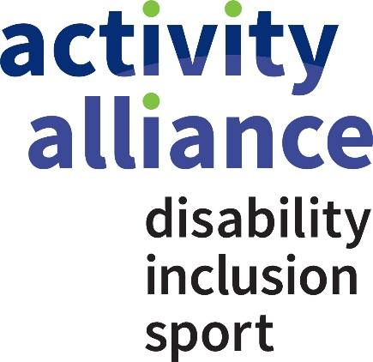

Our equality, equity, diversity and belonging statement

Activity Alliance is committed to being an organisation where people feel they belong and a place they can thrive in. This is whatever your background or personal circumstance. We are proud to be an equitable employer and partner. We expect the same from our partners and colleagues, right across the board and staff team.

We want to be a safe, welcoming, considerate, and responsible workplace. We value diversity as a strength, and we are better with greater equality and inclusion. Our ambitious vision and strong values are embedded in our governance and the development of paid and unpaid staff, trustees and volunteers.

The people who we work for and with make us a reputable organisation to know and trust. Nobody should miss opportunities or feel they do not belong at Activity Alliance.

We are proactive in taking steps to ensure meaningful inclusion for all the people who work for, and with us. We are legally obligated to comply with the general equality duty, as set out in section 149 of the Equality Act 2010. This prohibits discrimination because of the following protected characteristics:

* age
* disability
* gender reassignment
* marriage and civil partnership
* pregnancy and maternity
* race
* religion or belief
* sex
* sexual orientation

This policy statement applies to all staff, beneficiaries, trustees, volunteers and our partners.

This policy exists alongside other organisational documents such as Equality, Equity and Diversity Policy, Safeguarding policies, Diversity Inclusion Action Plan and People Plan.

**Review**

* Date of review: September 2024
* Date of next review: September 2025